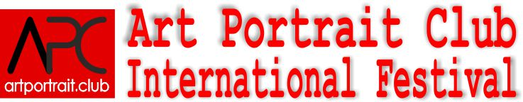  International Competition&Exhibition of Portrait Arts  Congress and Exhibition center "Danilovsky "  (Moscow, Dubininskaya street, 71/5,  metro station " Tulskaya")  (October 30- November 04, 2018) |  |  |  | Organizing Committee: www.artportrait.club ,  Email: info@artportrait.club  Skype: Euroartweek, ICQ 439-001-943  Mobile: 007-915-0120288,  Tel.: 007-495-5068044,  Tel/fax.: 007-499-2300545  Address: Address:8/2 Krimsky Val str., Moscow, 107049, Russia
Application form
 |  |  | Participation
Mark: Participation: Full-time __, On-line__
Mark: Category: STUDENT__, AMATEUR__, PROFI__, JUNIOR.
 |  | Personal information
Name, Surname:
Mobile:
Home phone:
Work phone:
Fax:
Date / year / place of birth:
Address with zip:
 |  | Contact information:
e-mail:
ICQ:
Skype:
http://www.
Links to publications:
Links to author’s works:
 |  | Previous participation in «ArtWeek»:
Mark, I participate: YES __; NO __.
Where (City): | When:(year, season): |  |  |  | Winning place:
(If necessary, continue the list)
 |  | For author’s presentation:
а) Education (name, course, faculty, graduation year):
б) memberships in artistic organizations and communities:
в) Participations in international exhibitions, contests, workshops, other projects (name, year):
г) CV or biography for publication on website and social networks:

Date: Name, Surname:
Pay attention: Each artwork needs separate label!

Number
Name of the author (co-authors):
Title of the art object:
Size (H) x (W) x (D):
Techniques:
Year:
Estimated cost:
Competition:
Nomination:
Professional category:

Number
Name of the author (co-authors):
Title of the art object:
Size (H) x (W) x (D):
Techniques:
Year:
Estimated cost:
Competition:
Nomination:
Professional category:

Number
Name of the author (co-authors):
Title of the art object:
Size (H) x (W) x (D):
Techniques:
Year:
Estimated cost:
Competition:
Nomination:
Professional category:

