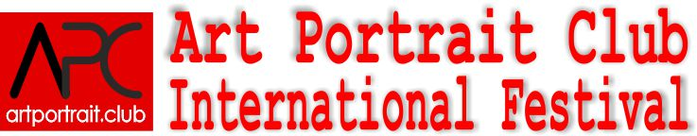

Nominations:
Pictorial portrait contest:
Section «Classical forms»:  Nominations:  - Classical male portrait  - Classical female portrait  - Child portrait  - Formal portrait  - Group portrait  - Family portrait  - Portrait of famous person  - Religious motif in portrait | Section «Experimental forms»:  Nominations:  - Portrait in an abstract manner  - Portrait of an avant-garde style  - Caricature  - Portrait-type - a collective image  - Portrait of famous person
Graphic portrait contest:
Nominations:  - Classical male portrait  - Classical female portrait  - Child portrait  - Group portrait  - Family portrait  - Portrait of famous person | - Religious motif in portrait  - Caricature  - Poster  - Portrait-type - a collective image  - Experimental portrait  - Engraving
Sculptural portrait contest: | Portrait contest in Arts&Crafts:
Nominations:  - Sculpture in the round – “head”  - Sculpture in the round - bust  - Sculpture composition  - Abstract sculpture  - Experimental sculptural forms  - Relief | Nominations:  - Decorative portrait  - Portrait: Inlay and painting  - Carving  - Souvenir production  - Mosaic  - Stained-glass  - Toys  - Untraditional materials in portrait
Textile portrait contest: | Portrait photography contest:
Номинации:  - Embroidery  - Fabric portrait  - Prints  - Batic | Nominations:  - Children  - Personal photography  - Group photography  - Glamour/ Boudoir  - Reporting photography
Organizing Committee:
www.artportrait.club , Email: info@artportrait.club
Skype: Euroartweek, ICQ 439-001-943
Mobile: 007-915-0120288, Tel.: 007-495-5068044,
Tel/fax.: 007-499-2300545
Address: Address:8/2 Krimsky Val str., of.352-5, Moscow, 107049, Russia

