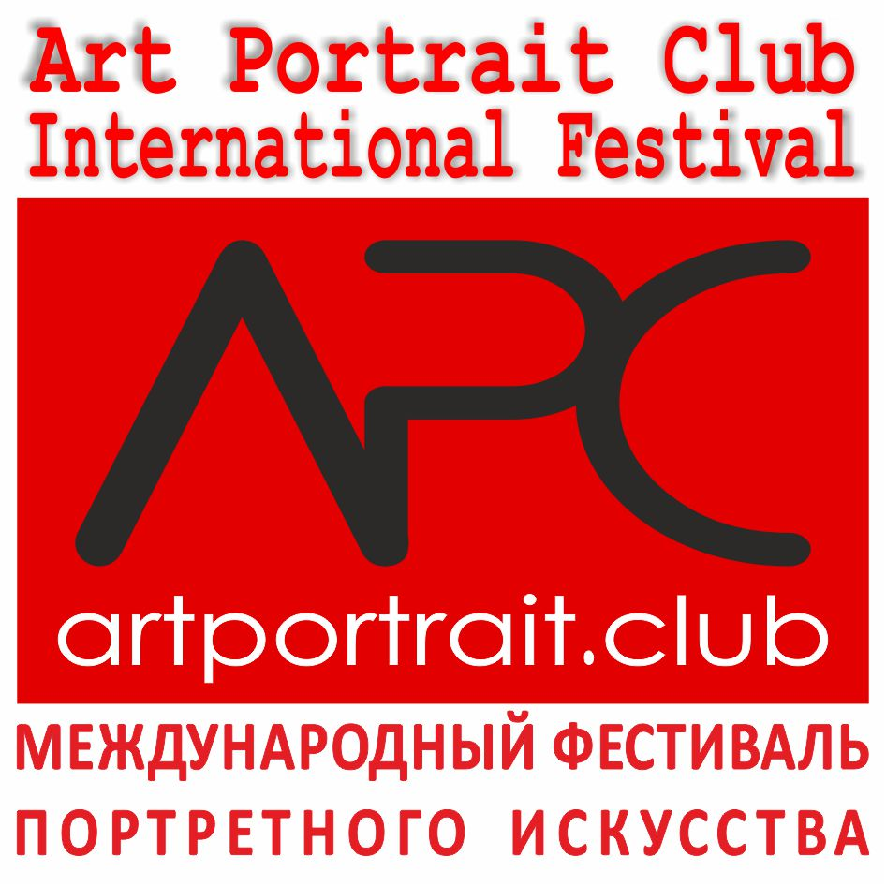

DATES AND ADDRESS
"Art Portrait Club Festival International" International Competition&Exhibition of Portrait Arts will be held from October 30 to November 04, 2018, at the Congress and Exhibition center "Danilovsky "(Moscow, Dubininskaya street, 71/5, metro station " Tulskaya")

TERMS AND CONDITIONS:
International competition of portraiture is organized by the World Found of Arts, and performed in several countries: Russia (Moscow), China (Beijing), Belarus (Minsk), Ukraine (Kiev).
The purpose of the competition - to attract widespread attention to the portrait genre, from both the artists and general audience.
Artists from all countries can participate in such competition. All participants have equal rights.

ART FEATURES
The contest work should be based on the image that characterizes the person as a person. Both naturalistic display of human and various experimental forms are allowed. The author chooses the necessary art tools - painting, graphics, sculpture, decorative arts, photography or video.
Each artist may submit for the contest any number of jobs. If the contest works is a series of works, one portrait work (competitive work) may include a series of works, united by one theme.

SPECIFICATIONS:
а) Size: the overall size shouldn’t be over 3.0×3.0 meters for painting, graphics, photography, textile works and 1.5×1.5x2.0 meters for sculpture, arts&crafts objects
b) Weight: under the 50 kilograms.
в) Material: Any kind of materials, except perishables.

ONLINE REGISTRATION AND WORK’S ASSIGNMENT:
There are two equal forms of participation: online and in absentia.
Registration is opened until 19 October 2018. Necessary set of materials:
1) Application form;
2) label (for each work);
3) copy of the payment of the registration fee.
4) author’s photo;
5) Image of competitive work in electronic form:
- In the case of static art objects – photo in .jpg, or .tiff formats;
- In case of participation in the "video" - video or link to youtube.

STEPS OF REGISTRATION:
There will be given a special identification number for each submitted work after the end of registration, which remains the same through the competition. The number will be sent by the email address provided during registration. The identification number used for all working materials should be maintained by the author. The selection process will be presented to the jury by their identification numbers.
SELECTION FOR EXHIBITION:
All registered work, corresponding to the requirements will be exhibited in the exhibition halls.
The exhibition is not allowed:
- Works that violate social norms;
- Work with the political context;
- Works that offend religious feelings and personality.

The winners will have the opportunity to participate in a subsequent traveling exhibitions and international forums.
Organizing Committee: www.artportrait.club , Email: info@artportrait.club
Skype: Euroartweek, ICQ 439-001-943
Mobile: 007-915-0120288, Tel.: 007-495-5068044,
Tel/fax.: 007-495-6407733
Address: 119049, Russia, Moscow, Krymsky Val, 8/2, office "Union of Artists".

